FINA6271 – Financial Modeling and Econometrics

# ***CASE No. 3***

# **October 12th, 2020**

# ***Team***

# Tiffany Tiono

# Aditya Tyagi

# Gamdan Abdullah

* When Date is before 30 July 2002, Dummy=0, which stands for the period before the Sox took place.
* When Date is after 30 July 2002, Dummy=1, which stands for the period after the Sox took place.

H0: βDateDummy =0

Ha: βDateDummy ≠ 0

Total Volatility of the market is the squared market returns.

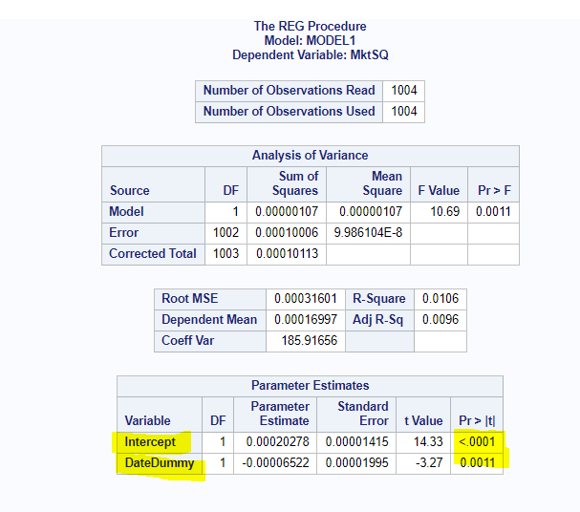

Since the P-Value of the T test is less than 0.05, we can reject H0 with reasonable confidence. Therefore, we are confident that the independent variables (DateDummy) offered some predictability of the dependent variable (Total volatility of the market) in the sample.

1. PERMNO=11850

H0: βDateDummy =0

Ha: βDateDummy ≠ 0

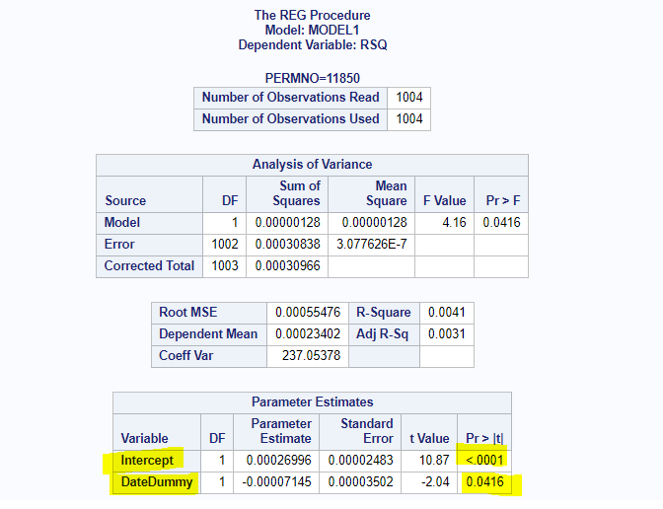

Since the P-Value of the T test is less than 0.05, we reject H0 with reasonable confidence. Therefore, we are confident that the SOx offered a significant impact on the idiosyncratic volatility of XOM.

1. PERMNO=12060

H0: βDateDummy =0

Ha: βDateDummy ≠ 0

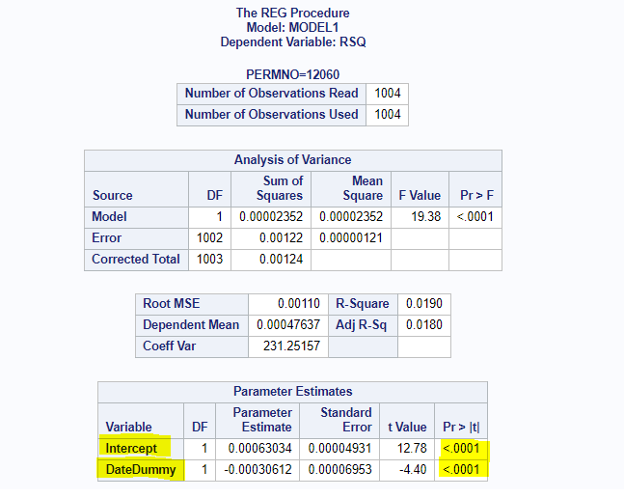

Since the P-Value of the T test is less than 0.05, we reject H0 with reasonable confidence. Therefore, we are confident that the SOx offered a significant impact on the idiosyncratic volatility of GE.

1. PERMNO=12490

H0: βDateDummy =0

Ha: βDateDummy ≠ 0

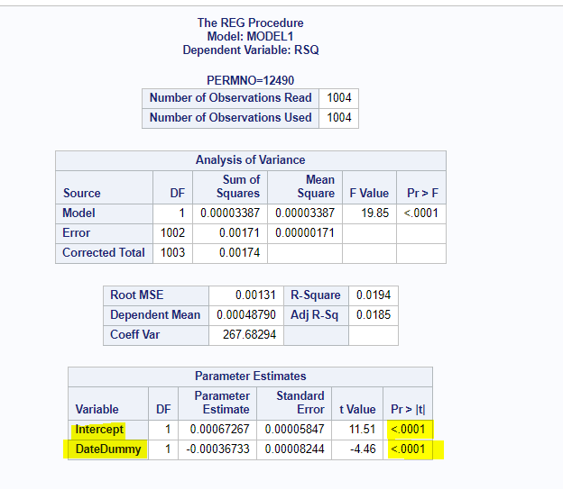

Since the P-Value of the T test is less than 0.05, we reject H0 with reasonable confidence. Therefore, we are confident that the SOx offered a significant impact on the idiosyncratic volatility of IBM.

1. PERMNO=22111

H0: βDateDummy =0

Ha: βDateDummy ≠ 0

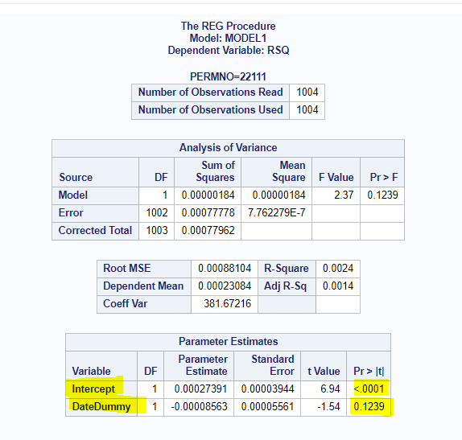

Since the P-Value of the T test is greater than 0.05, we fail to reject H0 with reasonable confidence. Therefore, we are confident that the SOx did not offer any significant impact on the idiosyncratic volatility of JNJ.

1. PERMNO=25785

H0: βDateDummy =0

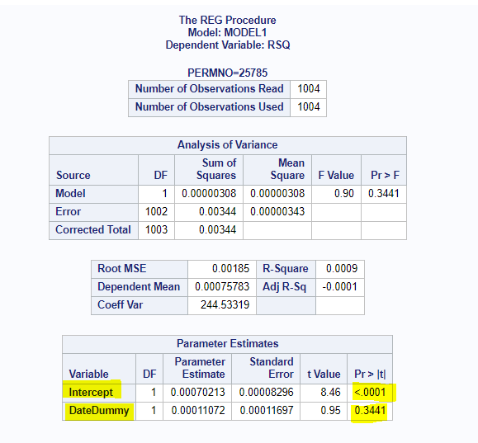Ha: βDateDummy ≠ 0

Since the P-Value of the T test is greater than 0.05, we fail to reject H0 with reasonable confidence. Therefore, we are confident that the SOx did not offer any significant impact on the idiosyncratic volatility of Ford.

2. PERMNO=11850

H0: βInterMkt =0

Ha: βInterMkt ≠ 0

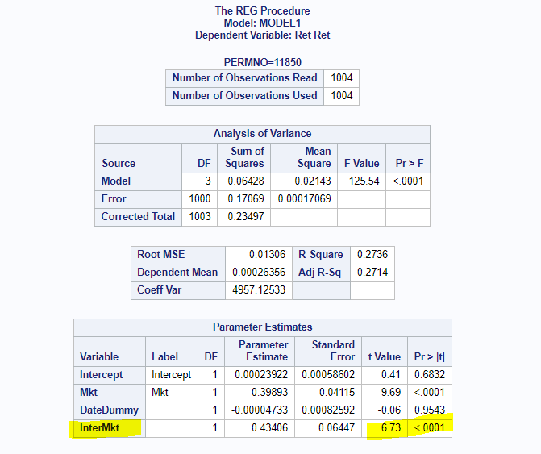

Since the P-Value of the T test is less than 0.05, we reject H0 with reasonable confidence. Therefore, we are confident that the SOx had a significant impact on the systematic risk of XOM.

1. PERMNO=12060

H0: βInterMkt =0

Ha: βInterMkt ≠ 0

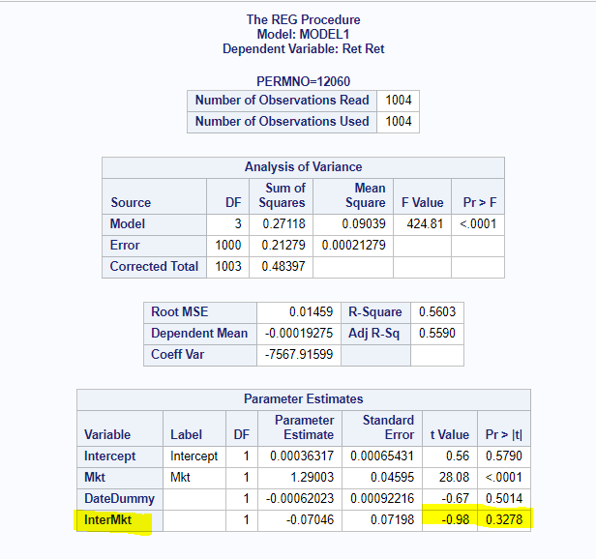

Since the P-Value of the T test is greater than 0.05, we fail to reject H0 with reasonable confidence. Therefore, we are confident that the SOx did not have any significant impact on the systematic risk of GE.

1. PERMNO=12490

H0: βInterMkt =0

Ha: βInterMkt ≠ 0

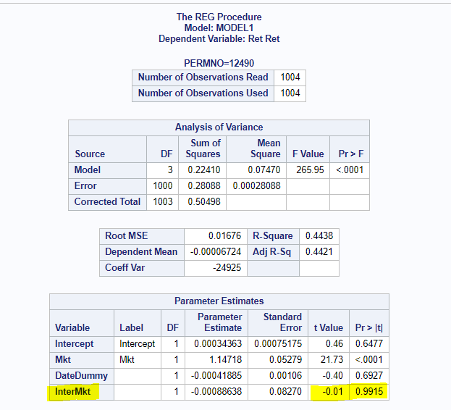

Since the P-Value of the T test is greater than 0.05, we fail to reject H0 with reasonable confidence. Therefore, we are confident that the SOx did not have any significant impact on the systematic risk of IBM.

1. PERMNO=22111

H0: βInterMkt =0

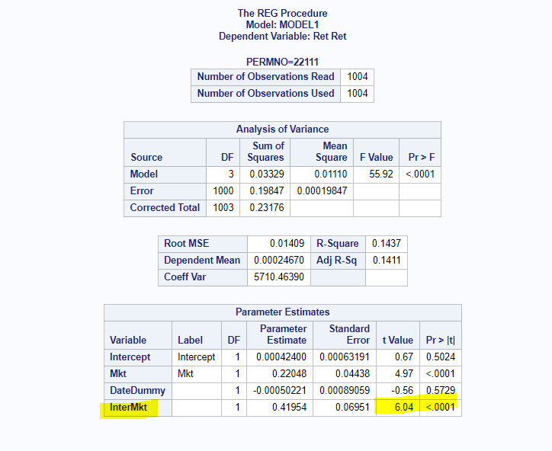Ha: βInterMkt ≠ 0

Since the P-Value of the T test is less than 0.05, we reject H0 with reasonable confidence. Therefore, we are confident that the SOx had a significant impact on the systematic risk of JNJ.

1. PERMNO=25785

H0: βInterMkt =0

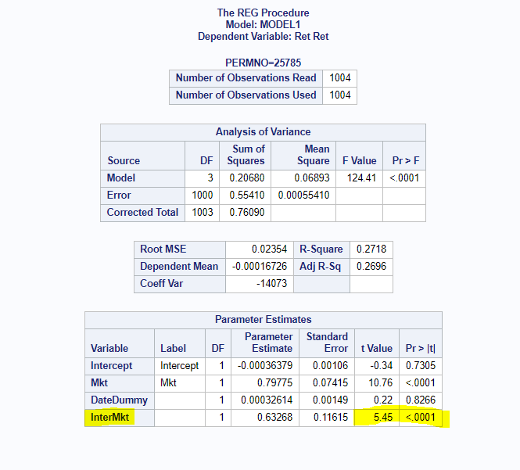Ha: βInterMkt ≠ 0

Since the P-Value of the T test is less than 0.05, we reject H0 with reasonable confidence. Therefore, we are confident that the SOx had a significant impact on the systematic risk of Ford.

1. 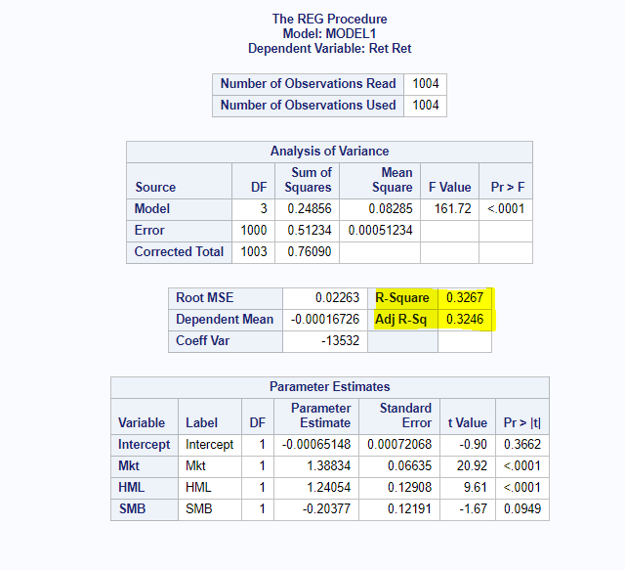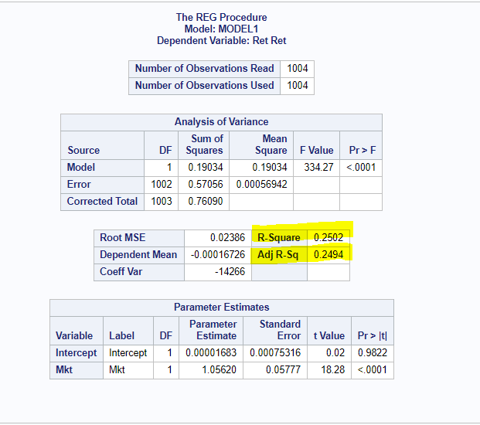

* For the R2 in the:

CAPM Model: R2: 25.02%

Fama-French Model: R2: 32.67%

The Difference between two models R2: 7.65%

So, in the sample, there is **7.65%** of additional proportion of variation in Ford’s return is predictable from the market return.

* For the Adjusted R2 in the:

CAPM Model: R2: 24.94%

Fama-French Model: R2: 32.46%

The Difference between two models R2: 7.65%

So, in the population, there is **7.52%** of additional proportion of variation in Ford’s return is predictable from the market return.

1. 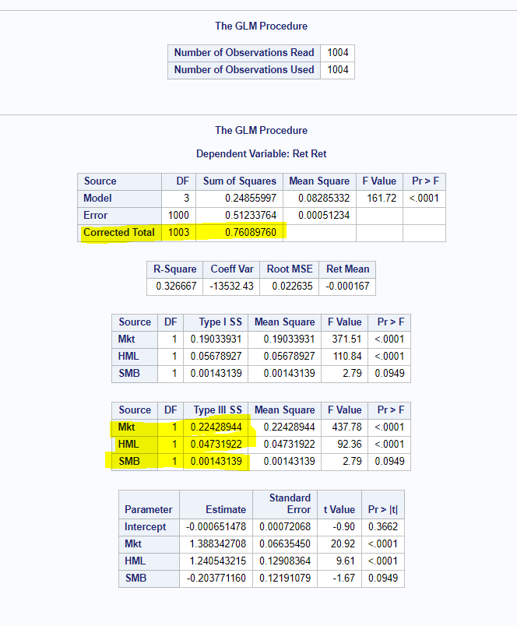

* PCDMKT=0.22428944/0.76089760 = 0.2947695459=29.48%

It means that 29.48 percent of the variability in Ford’s returns is uniquely predictable from MKT.

* PCDHML=0.04731922/0.76089760 = 0.06218868347=6.22%

It means that 6.22 percent of the variability in Ford’s returns is uniquely predictable from HML.

* PCDSMB=0.00143139/0.76089760 = 0.001881186115=0.19%

It means that 0.19 percent of the variability in Ford’s returns is uniquely predictable from SMB.

**Note that this factor is insignificant (P-value is greater than 0.05).**

1. 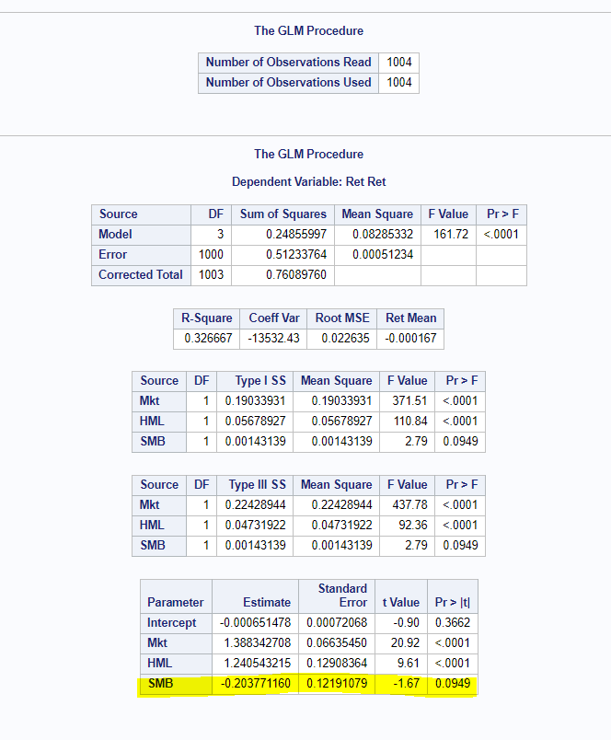

H0: βSMB ≥ 0

Ha: βSMB < 0

**First condition**: Sign of slope consistent with Ha?

Yes. -0.203771160 is less than 0.

**Second Condition**: P-value divided by 2 less than 0.05?

Yes. 0.0949/2= 0.04745 is less than 0.05.

Since both required conditions are satisfied, we reject H0 with a reasonable confidence. Therefore, we have reasons to believe that an increase in SMB is associated with a decrease in Ford’s returns.

1. 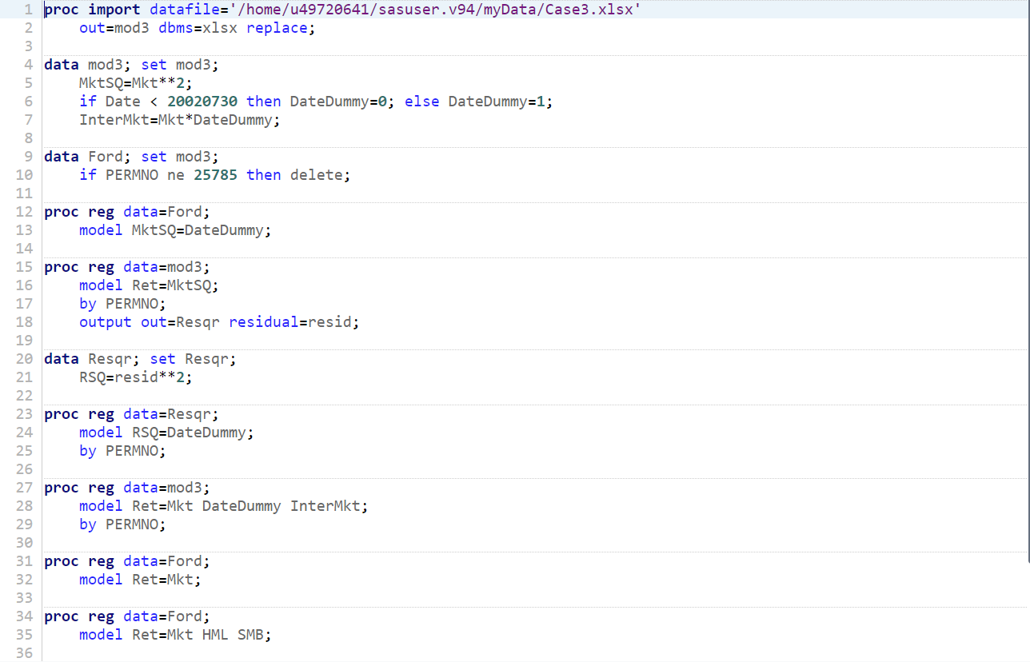 **SAS Codes:**